For Loop example  
# To print 1 to 10 numbers

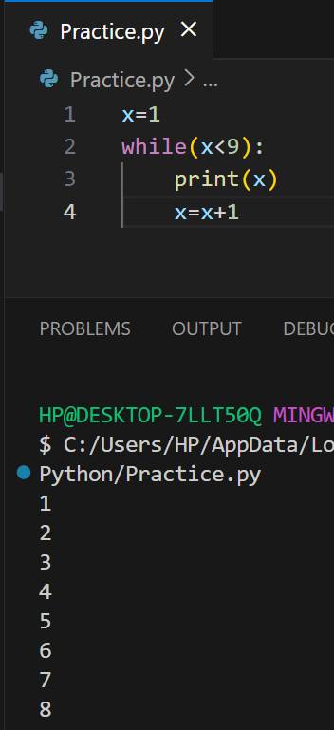

# To print 1 to 100 numbers

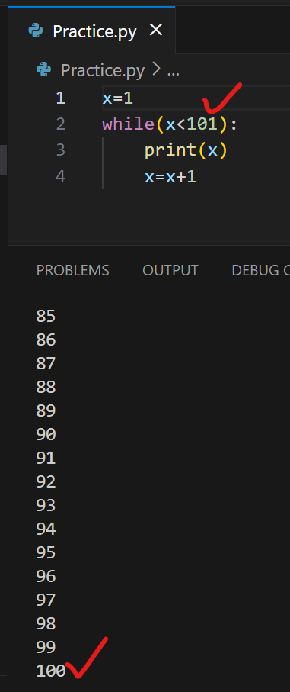

# To print Name 100 times

Add name in strings – “”

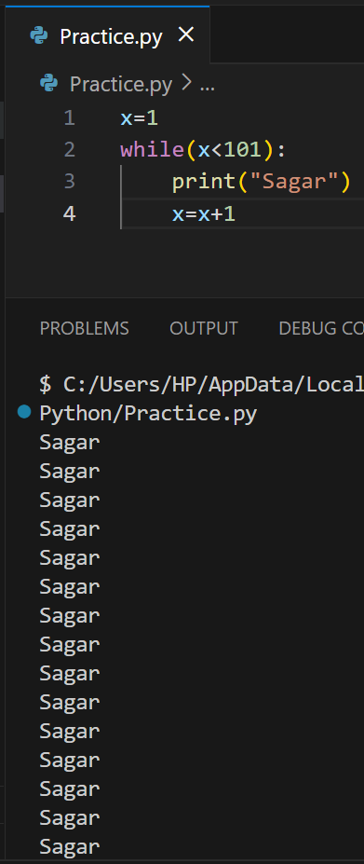

# We are printing “x” value after execution

So we get output

2 to 8

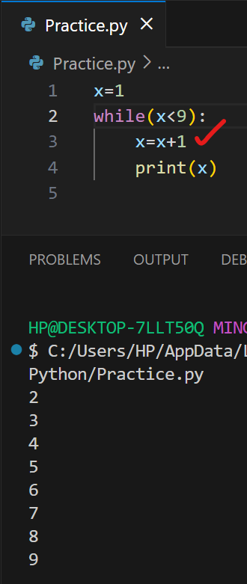

# Infinite Loop example  
It will execute the “x” value till memory capacity

Terminal will struck / We need to delete the terminal in VS code this situation

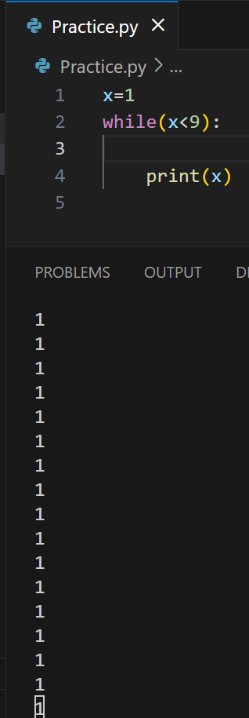

#Print even number till 9

* We can get the even numbers which is divided by 2 is even numbers
* We need to follow the indentation here

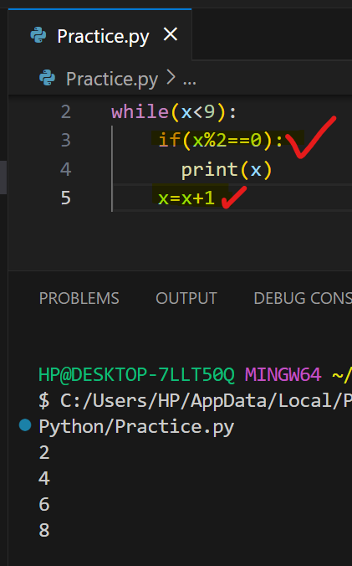

#To print ODD numbers 1 to 10 numbers

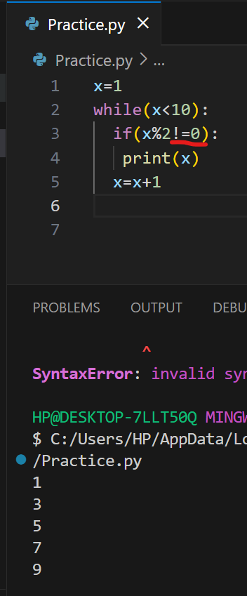

#We need to print the values 1 to 90 but also break the value 55 in middle

* By using break we can break the loop

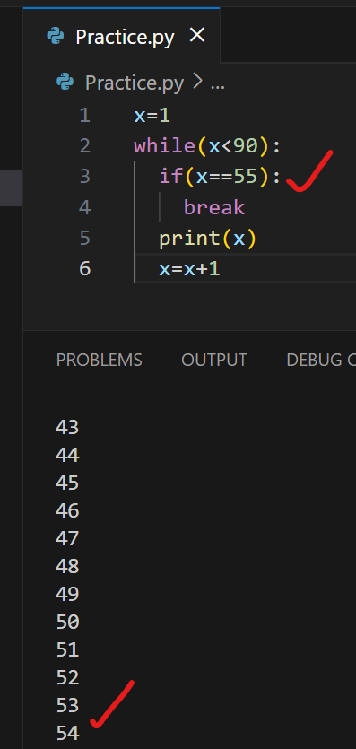

#Using “Continue” method

Skip the the number

*55 number not printed below

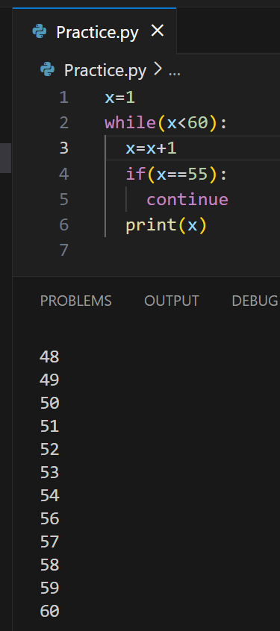

#We can keep 🡪 Else block

To print required statement like below

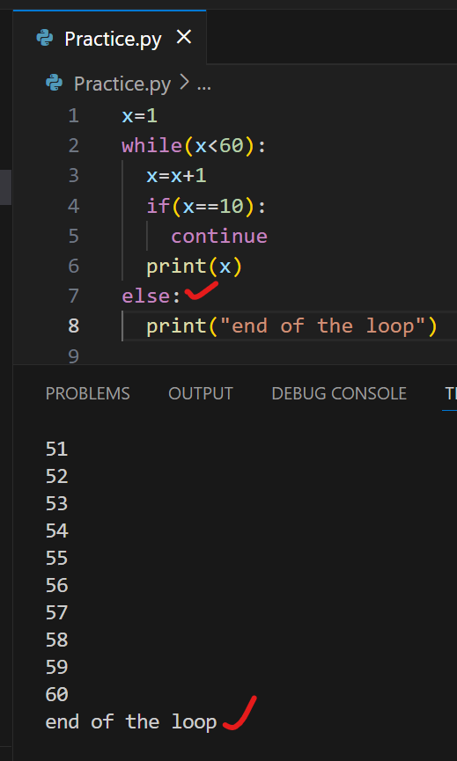

#We can also write the code in 1 line

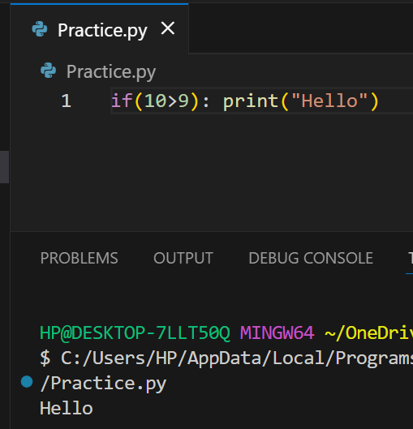

#Short Hand IF …Else condition / Use case OR Turn operator also same

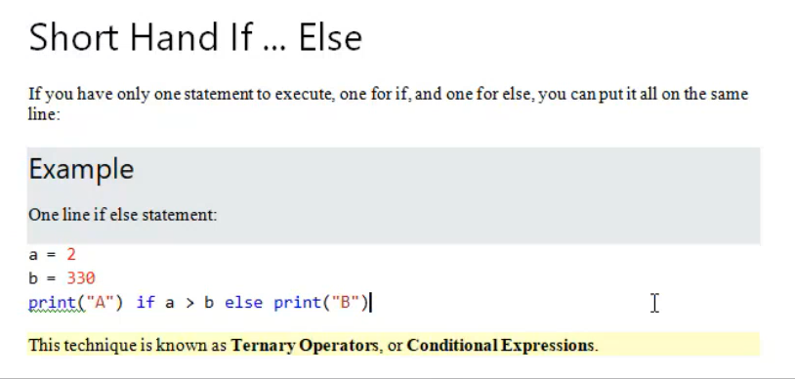

* a>b if the condition is true / It will print the a=20 / If the given condition is not true it will print the else block.

